MID ( 22-23)

1.
a) Watch Problem.
Sol^{n}:
Already Solve.

1. b)
i) Java programs normally go through five phases: _________, _________, _________, _________ and _________.
ii) Java programmers concentrate on creating _________, which contain fields and the set of methods that manipulate those fields and provide services to clients.
iii) Keyword _________ requests memory from the system to store an object, then calls the corresponding class's constructor to initialize the object.
iv) All programs can be written in terms of three types of control structures: _________, _________ and _________.
Sol^{n}:
i) Java programs normally go through five phases: edit, compile, load, verify and execute.
ii) Java programmers concentrate on creating classes, which contain fields and the set of methods that manipulate those fields and provide services to clients.
iii) Keyword new requests memory from the system to store an object, then calls the corresponding class's constructor to initialize the object.
iv) All programs can be written in terms of three types of control structures: sequence, selection and iteration.

1.
c) Write a Java application that calculates and prints the sum of the integers from 1 to 20. Use a while statement to loop through the calculation and increment statements. The loop should terminate when the value of i becomes 21.
Sol^{n}:
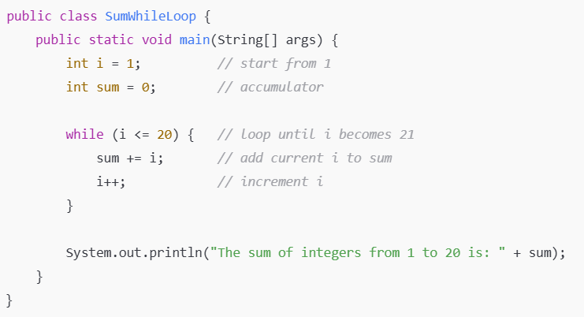

2.
a) "To reduce the complexity and simplify the language, multiple inheritance is not supported in java"-justify the statement with example. (3 marks)
Sol^{n}:
In Java, multiple inheritance of classes is not supported (a class cannot extend more than one class).
Justification:
- If multiple inheritance were allowed, the compiler would face ambiguity problems (the diamond problem).
- Example: If two parent classes have methods with the same name, the child class will be confused about which method to inherit.
- To reduce this complexity and ambiguity, Java designers did not allow multiple inheritance with classes.
- Instead, Java supports multiple inheritance through interfaces (a class can implement multiple interfaces).
Example (Ambiguity Problem)
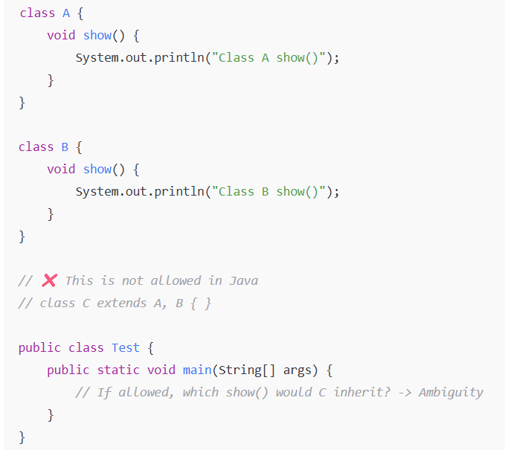
To solve this, Java uses interfaces:
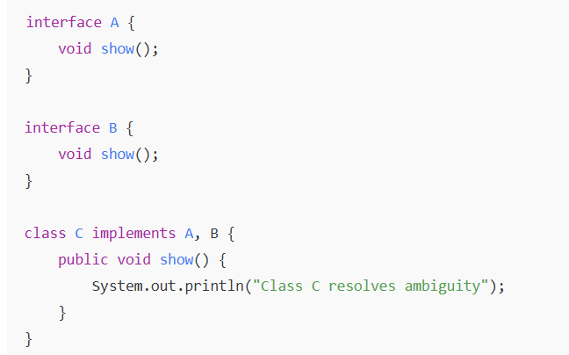
2. b)
Write down the syntax of Inheritance in Java? (1/2 marks)
Sol^{n}:
In Java, inheritance is achieved using the extends keyword.
Syntax:
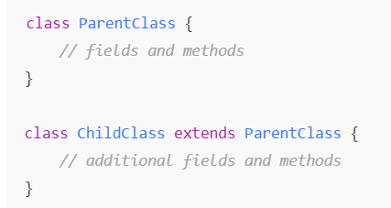
Here, ChildClass inherits the properties and methods of ParentClass.

2. c)
Will the following code be successfully compiled? If yes, what is the output? (2/3 marks)
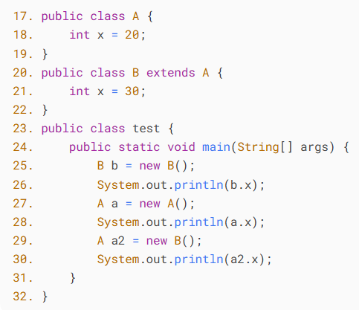
Sol^{n}:
Compilation check
- Problem: In Java, you cannot have more than one public class in the same .java file.
- In Java, only one public class is allowed per file, and the file name must match that class.
- Here, you have public class A, public class B, and public class test all in the same file. This will cause a compilation error.
- Fix: Either remove the public keyword from A and B, or split them into separate files named A.java, B.java, and test.java.
So, as-is, this code will NOT compile.

